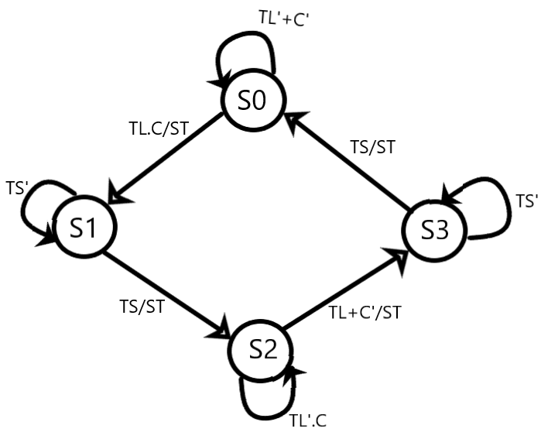

State S0 is the default/reset state in which the main road's light stays green for the major traffic to pass.

**At state S0**

When the sensor does not detect any car (C’) and the long time interval is not zero (TL’), the state remains at S0 only.

If the sensor detects a car or the long time (TL) goes zero, it goes from state 0 to state 1 and the timer starts for long or short interval. Main road light turns red and the side road light turns green.

**At state S1**

When the short time is not zero (TS’), the state remains at S1 only and side road light stays green.

When the short time goes zero (TS), the start timer (ST) is initiated, and the state goes from 1 to 2 where the side road light turns red and the main road light turns green again.

**At state 2**

When the long timer is not zero (TL’) and no vehicle is detected(C), the main road light stays green and it remains at S2 only.

When a vehicle is detected on the side road or long timer goes zero(TL), the start timer is initiated and we go from state 2 to 3 with the main road light turning red and side road green.

**At state 3**

When the short timer is not equal to zero (TS’) it remains on state 3 only with side road light green and main road light red.

When the short timer ends, that is goes to zero(TS), the start timer is initiated and the main road light turns green and side road turns red and it goes to state 0 again.